**Jun**

2023

**The AED Model Assessment, Reporting, and Visualisation Library (MARVL) v1.1**

**User Instruction**

**(DRAFT)**



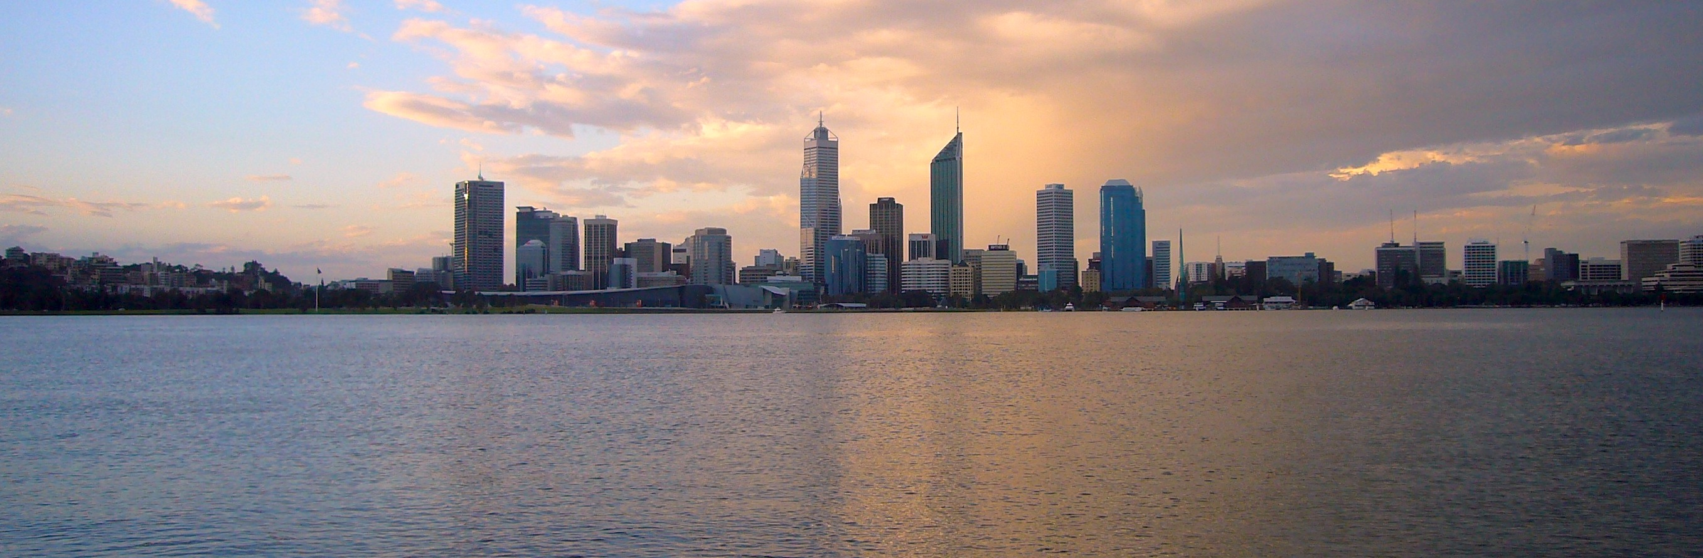

# About This Instruction

This document is a User Instruction for the AED Model Assessment, Reporting, and Visualisation Library (MARVL) package. The MARVL package is an integrated software package for visualizing the model outputs and observational datasets, and evaluating the model performance. One of the key challenges for water quality modelling is to assess the model performance against field observations that typically include plenty of biogeochemical variables, exist at multiple sites, and are provided by multiple agencies in different formats. To handle this challenge, the AED research group has developed a series of data processing framework to store the data in a uniform format that is compatible to the AED outputs. At the same time, the group has developed a series of model assessment methods and scripts that were specifically designed to be compatible with the AED data repository and model outputs. The package is a collection of the past AED in-house scripts, and has been refined with uniform and easier user interfaces. This instruction provides guidance for using the MARVL package for visualizing the model outputs and/or data. For the AED variables, units, and science the readers are referred to the AED Science Manual (<https://aquaticecodynamics.github.io/aed-science/>, Hipsey et al., 2022).

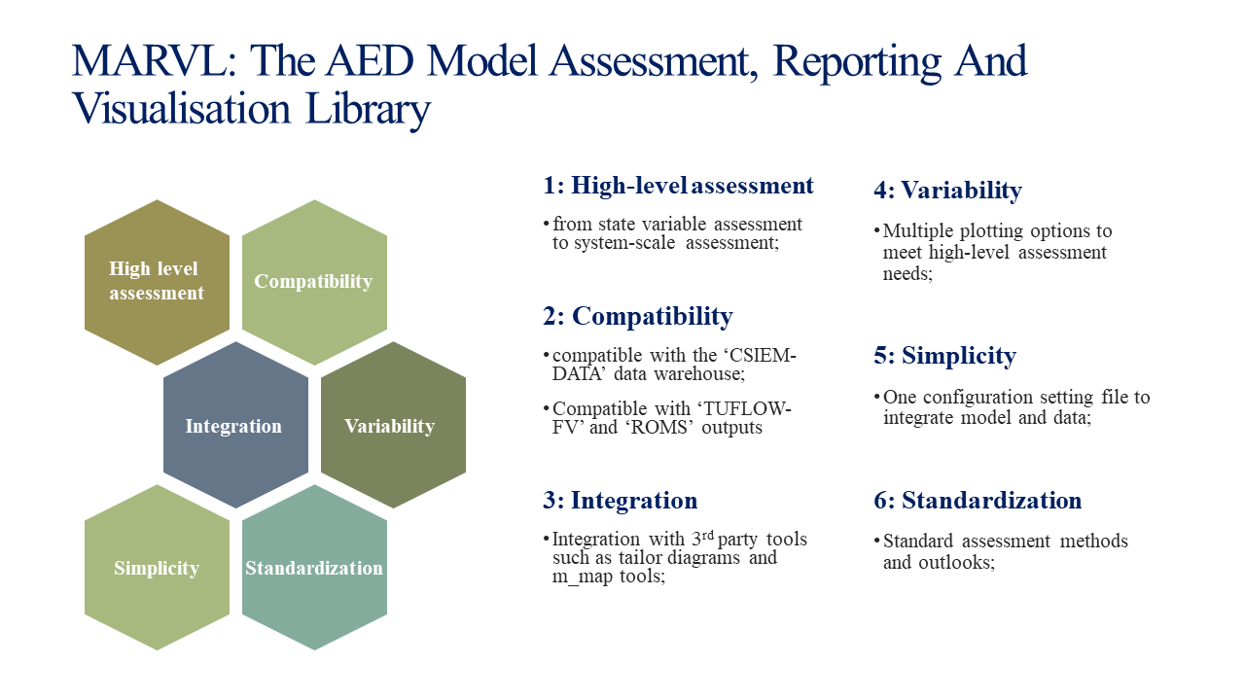

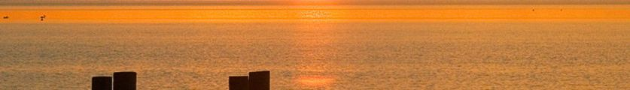

## CONTRIBUTORS

*Peisheng Huang a*

*Brendan D. Busch a*

*Matthew R Hipsey a*

a Aquatic Ecodynamics, School of Earth and Environment, The University of Western Australia, Crawley WA 6009, Australia.

## ACKNOWLEDGEMENTS

The authors would like to acknowledge technical support for AED development by Casper Boon. Some functions used in MARVL for processing TUFLOW and AED outputs are originally developed by BMT.

## REVISION AND DISTRIBUTION HISTORY

|  |  |  |  |  |  |
| --- | --- | --- | --- | --- | --- |
| Issue | Issued to | Qty | Date | Reviewed | Approved |
| *V1 (prelim)* |  | *e* | *25 Feb 2023* | *Matt Hipsey* |  |
| *V1.1 (prelim)* |  | *e* | *23 Jun 2023* | *Matt Hipsey* |  |
|  |  |  |  |  |  |

## RELEASE STATUS:

Confidential: No

**DRAFT – UNDER REVIEW**

## DOCUMENT DETAILS

Citing this report:   
Huang, P., Busch B., Hipsey, M.R., 2023. The AED Model Assessment, Reporting, and Visualisation Library (MARVL) v1, User Instruction. AED Report #R**, The University of Western Australia, Perth, Australia. 39pp.

Copyright © 2016. The University of Western Australia,

# Contents

About This Instruction 2

CONTRIBUTORS 3

ACKNOWLEDGEMENTS 3

REVISION AND DISTRIBUTION HISTORY 3

RELEASE STATUS: 3

DOCUMENT DETAILS 3

Contents 4

1. Introduction 6

1.1 Overview 6

1.2 Repository Organisation 6

1.3 Execution Instruction 6

1.4 Update history 7

2. MARVL Modules 7

2.1 master module 7

Configuration Summary 8

Configuration Example 10

2.2 time-series plotting module 11

Configuration Summary 13

Configuration Example 16

Example Output 17

2.3 transect plotting module 17

Configuration Summary 18

Configuration Example 20

Example Output 21

2.4 transect stacked area plotting module 21

Configuration Summary 22

Configuration Example 24

Example Output 25

2.5 transect exceedance plotting module 25

Configuration Summary 26

Configuration Example 28

Example Output 29

2.6 site profiling plotting module 29

Configuration Summary 30

Configuration Example 31

Example Output 32

2.7 sheet map plotting module 32

Configuration Summary 33

Configuration Example 35

Example Output 35

2.8 curtain plotting module 36

Configuration Summary 37

Configuration Example 39

Output Example 39

References 41

# 1. Introduction

## 1.1 Overview

MARVL is an integrated software package for visualizing the model outputs and observational datasets, and evaluating the model performance. It is also able to carry out high-level system assessment such and environmental response functions and nutrient budgeting analysis, though certain pre-processing steps are required to prepare the data for the high-level system assessment. The current MARVL repository is a collection of AED in-house scripts that have been developed during previous research projects for model assessment, and has been refined with uniform and easier user interfaces. At the moment, the AED-MARVL was designed with the following features:

* Multiple visualizing options such as time-series, transect view, curtain view, site profiling;
* Standard and advanced performance evaluating methods;
* One configuration file for all visualizing functions;
* Uniform outlook (e.g. font style and size, figure resolution) of the figures and animations;
* Option to use YAML style of configurations that can be shared with other plotting software such as R and python;

Following visualizing functions are available in MARVL:

* Time series (with options to show observational data and perform model skill assessment);
* Transect (with options to show observational data on the same transect);
* Transect stacked area for comparing water quality compositions;
* Transect exceedance for comparing water quality levels against guidelines;
* Site profiling of selected water quality variables;
* Sheet plotting and animations;
* Curtain plotting and animations;

High-level systematic assessment of water quality response of to environmental factors and nutrient budgeting analysis have been developed using many of the basic functions of MARVL. However, these high level assessments require several pre-processing steps to prepare data for the assessment, and the configurations and pre-processing varied in different case studies. Therefore, there is still no straightforward script for these high level assessments. We have included the workflow in this document and examples scripts/outputs of the high-level assessments in the MARVL repository. Users of MARVL can follow the workflow and modify the scripts to produce the assessment outcomes of their studies.

The plotting functions have been tested within several case studies, including Coorong Lagoon, Cockburn Sound, and Lake Erie, and examples are included in the current repository. However, MARVL is still in its developing phase. We are expecting feedbacks for us to improve the user experience, as well as functionalities.

## 1.2 Repository Organisation

The repository is organized as followed:

* `sources`: plotting scripts and libraries for MARVL;
* `examples`: place holder for site-specific configurations and recommended place for plotting results;
* `docs`: place holder for documenting MARVL science and user instructions;

## 1.3 Execution Instruction

Step 1: Colone the `aed-marvl` repository onto local computer

Step 2: Open Matlab (version 2020 or later versions), go to the local `aed-marvl` folder and add the paths to tools/libraries by entering

addpath(genpath('./'))

Step 3: Go to your working folder, edit the `MARVL.m` to configure the plots (use the 'MARVL.m' under other project folder as templates);

Step 4: Under the working folder path, start the plotting by entering

run_AEDmarvl('./MARVL.m','matlab')

or if you wish to use YAML style configuration

run_AEDmarvl('./MARVL.m','yaml')

## 1.4 Update history

* V1.0 – released on 25 Feb 2022, contains the first version of MARVL package (see MARVL user instruction V1.0.docx);
* V1.1 – released on 23 June 2022, with new features of:
  + Add option of Tailor diagram for showing model performance skills;
  + Integrate ‘m_map1.4’ third-party package for improving sheet animations and plots;
  + Add option of current vectors on to the sheet plotting module;
  + Add option of current vectors on to the transect plotting module;
  + Improve the site profiling module for plotting model outputs at selected sites against mooring records;

# 2. MARVL Modules

This section introduces the configuration of the MARVL.m file for the visualizing plotting. The configuration file is composed in the form of modules, where the master module is for choosing the plotting functions and defining basic features, and the sub-plotting modules for specifying details in the corresponding plotting functions.

## 2.1 master module

The configuration of the master module includes choosing the MARVL modules (by commenting/uncommenting out options), model state variables, model path, field data path, and general plotting features. A summary of master module configuration is provided in Table 2.1 and an example is provided after the table.

NOTE: user can include multiple model outputs for time series and transect comparisons.

### Configuration Summary

Table 2.1 Summary of master module configuration

|  |  |  |  |
| --- | --- | --- | --- |
| Field name | Description | Options | Comments |
| modules | select plotting function(s) by commenting/uncommenting out the options | 'timeseries';... | time-series plot, with option to add observation and performance matrix |
| 'transect'; ... | transect-view of water quality along a defined longitude |
| 'transect_stackedArea'; ... | transect-view of water quality components, such as TN vs [PON+DON+NH4+NO3] |
| 'transect_exceedance'; ... | transect-view of water quality against defined guildlines (thresholds) |
| 'sheet'; ... | map-view of water quality, with options of 'movie (animation)' and time-averaging |
| 'curtain'; ... | curtian-view of water quality, with options of 'movie (animation)' and time-averaging |
| 'site_profiling'; ... | profiling of water quality at selected sites |
| 'sediment_profiling'; .. | profiling of sediment quality at selected sites (under development) |
| varname | define water quality variables for plotting | column 1 is the AED variable name (see AED manual for names of the variables), column 2 is the user-defined names in the plot | further options available, including 'TNTP' (calculating TN:TP stoichoimetry ratio in time series), 'DINDIP' (DIN:DIP stoichiometry ratio) and 'PONDON' (PON:DON ratio) |
| ncfile.name | define the path and name of model output file for plotting |  | user can define multiple model output to be compared in one figure |
| ncfile.legend | define legend for model to show in plots |  | user to assign a legend for each model |
| ncfile.tag | define model type, optional | ‘TFV' (tuflow) by default, with option 'ROMS' to plot post-processed ROMS output | no tag is required if is using TUFLOW-FV outputs |
| add_fielddata | option to add field data on timeseries and transect plot | 1: add field data; 0: no field data |  |
| fielddata_matfile | path of the field data in .mat format |  | The field data must be pre-processed according to the AED format for variable names, site descriptions and data organization and saved in .mat format |
| font | font name for the plots | see font name options in matlab (by entering 'listfonts' in matlab window),'Times New Roman' by default |  |
| fontsize | Font size in main plot | 8 by default |  |
| xlabelsize | font size for x axis label | 9 by default |  |
| ylabelsize | font size for y axis label | 9 by default |  |
| titlesize | font size for titles | 10 by default |  |
| legendsize | font size for legend | 6 by default |  |
| visible | option to show figure while plotting | on' or 'off' |  |

### Configuration Example

***Example master module configuration:***

master.modules = {...

'timeseries';...

'transect'; ...

% 'transect_stackedArea'; ...

% 'transect_exceedance'; ...

% 'sheet'; ...

% 'curtain'; ...

% 'site_profiling'; ...

% 'sediment_profiling'; ...

};

% state variable Configuration

% column 1: AED names;

% column 2: user-defined names

master.varname = {...

'SAL','Salinity';...

'TEMP','Temperature';...

'WQ_OXY_OXY','DO';...

'WQ_DIAG_PHY_TCHLA','TCHLA';...

'WQ_DIAG_TOT_TN','TN';...

'WQ_DIAG_TOT_TP','TP';...

'WQ_NIT_AMM','NH_4';...

'WQ_NIT_NIT','NO_3';...

'WQ_PHS_FRP','PO_4';...

'WQ_DIAG_TOT_TSS','TSS';...

'WQ_DIAG_TOT_TOC','TOC';...

'WQ_OGM_DOC','DOC';...

'WQ_DIAG_TOT_TURBIDITY','Turbidity';...

'DINDIP','DIN/DIP ratio';...

'PONDON','PON/DON ratio';...

'TNTP','TN/TP ratio';...

};

master.add_human = 1; % option to use user-define names, if 0 use AED names

% Models

master.ncfile(1).name = 'W:/CDM2022/eWater2022-scenarios-VH-paper-warmup/output_basecase_005/eWater_basecase_005_all.nc';

master.ncfile(1).legend = 'Basecase';

% field data, stored in standard AED .mat standard format

master.add_fielddata = 1;

master.fielddata_matfile = '.\data\store\archive\cllmm.mat';

master.fielddata = 'cllmm';

% general plotting features

master.font = 'Times New Roman';

master.fontsize = 8;

master.xlabelsize = 9;

master.ylabelsize = 9;

master.titlesize = 10;

master.legendsize = 6;

master.visible = 'off'; % on or off

## 2.2 time-series plotting module

The time-series plotting module is one of the core modules of MARVL. In a basic model performance assessment, the model outputs at the same location and same time of field observations are extracted and the results are compared with the observations to calculate the model skills. However, it is often seen in water quality study that multiple sites (from regular monitoring or occasional surveys) exist in an interested model domain and it is critical for the model to capture the spatial variation rather than just one site. This is especially important for areas with quick and steep bathymetry change, where both the field observations and model present strong spatiotemporal variations. Therefore, this module is designed to be able to show observations from one or multiple sites within a certain area, in comparison to the median and percentiles of model results within the same area. The users can define the size of interested area in GIS polygon files to cover just one site or a larger area with multiple sites.

The module also includes standard and advanced statistic methods to evaluate model performance scores. There are seven statistic methods available in the time-series module for assessing the model performance skills (Table 2.2.1). The readers are referred to these nice publications of Bennett et al. (2013) and Hipsey et al., (2020) for the detailed overview and discussion of these assessment methods. Users can define which method(s) to be included in performance assessment via the configuration of the ‘skills’ field in the module.

The module provides two options for comparing the observations and model prediction when multiple sites exist at the same time in a define polygon. These options can be configured in the ‘scoremethod’ field of the module, which include:

* Median: when this option is activated, the median value of all observations is compared to the median value of model predictions. E.g.

where and are the 50th percentile of observation and model prediction at the time of *i*th observation, respectively.

* Range: when this option is activated, the median value of all observations is compared to the range of model prediction in the define polygon. For example, if the user define the model range to be ‘timeseries.pred_lims = [0.05,0.25,0.5,0.75,0.95]’, then the range is taken as the 5th and 95th of model prediction, and the model prediction is considered satisfying if the median observation sit within the range. Otherwise the nearest prediction of the range to the median prediction is used. E.g.

where and are the 5th and 95th percentile of model prediction at the time of *i*th observation, respectively.

Table 2.2.1 Summary of model performance skills in the time series module, where *n* is the number of observations of *O* and model prediction of *P*. *Oi* and *Pi* denote the *i*th observation and prediction, respectively, and and denote the mean value of observations and predictions.

|  |  |  |
| --- | --- | --- |
| Model skills | Description | Numerical method |
| R | correlation coefficient |  |
| BIAS | bias of model prediction relative to observations |  |
| MAE | mean absolute error |  |
| NMAE | normalized mean absolute error to mean observation |  |
| RMS | root-mean square error |  |
| NRMS | normalized root-mean square error to mean observation |  |
| MEF | model efficiency, also called Nash-Sutcliffe efficiency |  |
|  |  |  |

A summary of time series module configuration is provided in Table 2.2.2. Example configuration and output are provided after the table.

### Configuration Summary

Table 2.2.2 Summary of time series module configuration

|  |  |  |  |
| --- | --- | --- | --- |
| Field name | Description | Options | Comments |
| start_plot_ID | select which variable to start plotting |  | refer to the setting in master.varname |
| end_plot_ID | select which variable to finish plotting |  | refer to the setting in master.varname |
| plotvalidation | option to add field data | 1: add field data; 0: no field data |  |
| plotmodel | option to add model results | 1: add model results; 0: no model results |  |
| plotdepth | option to select surface or bottom layers | surface and/or bottom | if both surface and bottom are configures, both layers will be added onto same plots and used together for model performance matrix |
| edge_color | define edge colors for field data symbols |  |  |
| depth_range | define depth range for plotting |  | [0 5000] by default |
| validation_minmax | option to add min and max values of observations | 1: add max/min data; 0: no max/min data; | 0 by default |
| isModelRange | option to add model results percentiles | 1: add percentile range; 0: no percentile range; | 0 by default |
| pred_lims | define percentile limits for range plotting | 5 numbers between 0 -1 | [0.05 0.25 0.5 0.75 0.95] by default |
| alph | transparency of range plot | 0 - 1 | 0.5 by default |
| isFieldRange | option to add monthly historical field data range | 1: add range; 0: no range | 0 by default |
| fielddprctile | define field data percentile range if isFieldRange==1 | range between 0 to 100 | [10 90] by default |
| isHTML | option to add all plots into one HTML page | 1: add to HTML; 0: no HTML | 0 by default |
| polygon_file | define the polygon file for zones/sites/areas |  |  |
| plotAllsites | option to plot all sites in the polygon file | 1: plot all site; 0: selected sites | 1 by default |
| plotsites | define site IDs for plotting if plotAllsites==0 |  |  |
| add_error | option to calculate model performance matrix | 1: calculate; 0: not calculate | 0 by default |
| isSaveErr | option to save the performance matrix in a .mat file | 1: save; 0: not save | 0 by default |
| obsTHRESH | define the number of observations over which the performance statistics make sense | >5 | 5 by default |
| showSkill | option to show performance statistics in the plot | 1: show; 0: not show | 0 by default |
| scoremethod | option to select traditional or advanced method for performance skills | 'median' or 'range' | 'median': is a traditional method to compare the median observation values to median model results at selected sites; 'range': compare median observation values to the model percentile preditions |
| skills | option to select statistics skills | R; BIAS; MAE; RMSE; NMAE; NRMS; MEF |  |
| SkillStyle | Option to select performance skill style | ‘score’ or ‘tailor’ | Score: traditional way to present selected skills in a table on the figure;  Tailor: Tailor diagram to present correlation coefficient, RMSE, and standard deviation of both modelled/observed data on the figure. |
| outputdirectory | define directory to save plots |  |  |
| htmloutput | define directory to save HTML files |  |  |
| ErrFilename | define directory and file name to save the performance stastistics matrix |  |  |
| ncfile.symbol | define symbol for model results (surface and bottom) | '-' or '.' | user can define multiple model output to be compared in one figure |
| ncfile.colour | define colors for model median value plotting (surface and bottom) | RGB format for color definition |  |
| ncfile.col_pal_color_surf | define color for range plot of surface model results |  |  |
| ncfile.col_pal_color_bot | define color for range plot of bottom model results |  |  |
| datearray | define time period for plotting |  |  |
| dateformat | define time format to show in x axis | mm/yy' by default |  |
| istitled | option to add title | 1: add; 0: not add | 1 by default |
| isylabel | option to add y label | 1: add; 0: not add | 1 by default |
| islegend | option to add legend | 1: add; 0: not add | 1 by default |
| isYlim | option to define Y axis limits | 1: add; 0: not add | 0 by default |
| isGridon | option to add grid on | 1: add; 0: not add | 1 by default |
| dimensions | define figure dimensions in centimeters | [20 10] by default |  |
| dailyave | option to use daily average or raw model output internal | 1: daily-average; 0: raw model output interval | 0 by default |
| smoothfactor | option to smooth out the median model results | use odd numbers, such as 1 or 3 | 1 by default, no smoothing |
| legendlocation | define legend location | 'northeastoutside' by default |  |
| filetype | define figure file type | 'png' or 'eps' | 'png' to save figures to PNG format only; 'eps' to save figures in both EPS and 300dpi JPG formats |
| cAxis.value | define limits of Y axis | empty [] by default, matlab will automatically adjust the y limit |  |

### Configuration Example

**Example timeseries module configuration:**

timeseries.start_plot_ID = 1; % select which variable to plot

timeseries.end_plot_ID = 12;

timeseries.plotvalidation = 1; % Add field data to figure (1 or 0)

timeseries.plotmodel = 1;

timeseries.plotdepth = {'surface','bottom'}; % {'surface','bottom'} Cell-array with either one

timeseries.edge_color = {[166,86,40]./255;[8,88,158]./255}; % symbol edge color for field data, surface and bottom

timeseries.depth_range = [0.2 100];

timeseries.validation_minmax = 0; % option to add max/min observations

timeseries.isModelRange = 1; % option to plot model range with below percentile

timeseries.pred_lims = [0.05,0.25,0.5,0.75,0.95]; % must be 5 numbers

timeseries.alph = 0.5; % transparency

timeseries.isFieldRange = 0; % option to add plot field data range

timeseries.fieldprctile = [10 90];

timeseries.isHTML = 1;

% polygon file define the site areas

timeseries.polygon_file = 'E:\database\AED-MARVL-v0.4\Projects\Erie\GIS\erie_validation_v4.shp';

% option to plot all sites or selected sites

timeseries.plotAllsites = 1;

if timeseries.plotAllsites == 0

timeseries.plotsite = [1];

end

% section for model skill calculations

timeseries.add_error = 1;

timeseries.isSaveErr = 1;

timeseries.obsTHRESH = 5;

timeseries.showSkill = 1;

timeseries.scoremethod = 'range'; % 'range' or 'median'

timeseries.SkillStyle = 'score'; % 'score' for score table or 'tailor' for tailor diagram

% selection of model skill assessment, 1: activated; 0: not activated

timeseries.skills = [1,... % r: regression coefficient (0-1)

1,... % BIAS: bias relative to mean observation (%)

1,... % MAE: mean absolute error

1,... % RMSE: root mean square error

1,... % NMAE: MAE normalized to mean observation

1,... % NRMS: RMSE normalized to mean observation

1,... % MEF: model efficienty, Nash-Sutcliffe Efficiency

];

timeseries.outputdirectory = 'E:\database\AED-MARVL-v0.4\Projects\Erie\plotting\timeseries_testF\RAW\';

timeseries.htmloutput = 'E:\database\AED-MARVL-v0.4\Projects\Erie\plotting\timeseries_testF\HTML\';

timeseries.ErrFilename = 'E:\database\AED-MARVL-v0.4\Projects\Erie\plotting\timeseries_testF\errormatrix.mat';

timeseries.ncfile(1).symbol = {'-','-'};

timeseries.ncfile(1).colour = {[166,86,40]./255;[8,88,158]./255};% Surface and Bottom

timeseries.ncfile(1).col_pal_color_surf =[[254,232,200]./255;[252,141,89]./255]; % color1: 5-95 perc; color2: 25-75 perc

timeseries.ncfile(1).col_pal_color_bot =[[222,235,247]./255;[107,174,214]./255];

% plotting configuration

timeseries.datearray = datenum(2013,5:1:10,01);

timeseries.dateformat = 'mm/yy';

%timeseries.dimc = [0.9 0.9 0.9]; % dimmest (lightest) color

timeseries.istitled = 1;

timeseries.isylabel = 1;

timeseries.islegend = 1;

timeseries.isYlim = 1;

%timeseries.isGridon = 1;

timeseries.dimensions = [15 7.5]; % Width & Height in cm

timeseries.dailyave = 0; % 1 for daily average, 0 for model output interval.

timeseries.legendlocation = 'northeastoutside';

timeseries.filetype = 'eps';

for vvvv=1:size(MARVLs.master.varname,1)

timeseries.cAxis(vvvv).value = [ ];

end

### Example Output

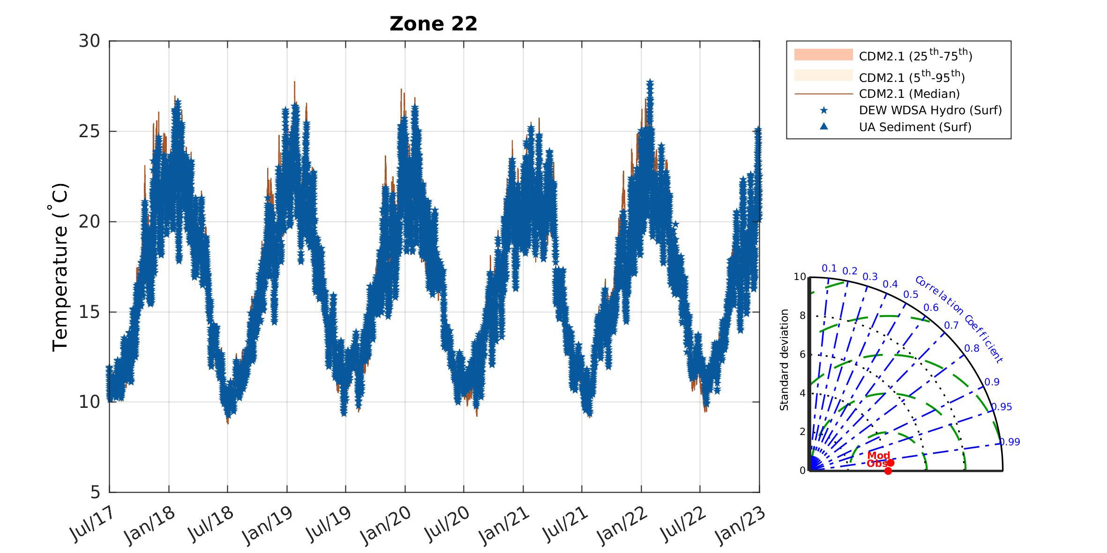

**Figure 2.2.** Example output of time-series module for water temperature in Coorong South Lagoon with the ‘Range’ method and Tailor diagram for model performance assessment.

## 2.3 transect plotting module

The transect plotting module is used for producing model predictions along a defined polyline, and has options to include observations within certain distance to the polyline. This module is useful especially in study site with significant spatial variations, such as an estuary crossing a freshwater-marine spectrum, or coastal system with shallow to deep water gradients. Users can define time period(s) for the transect, add model prediction ranges and box plots of observations on top of model results. A summary of transect module configuration is provided in Table 2.3. Example configuration and output are provided after the table.

### Configuration Summary

Table 2.3 Summary of transect module configuration

|  |  |  |  |
| --- | --- | --- | --- |
| Field name | Description | Options | Comments |
| start_plot_ID | select which variable to start plotting |  | refer to the setting in master.varname |
| end_plot_ID | select which variable to finish plotting |  | refer to the setting in master.varname |
| plotvalidation | option to add field data | 1: add field data; 0: no field data |  |
| plotmodel | option to add model results | 1: add model results; 0: no model results |  |
| isRange | option to add model results percentiles | 1: add percentile range; 0: no percentile range; | 0 by default |
| pred_lims | define percentile limits for range plotting | 5 numbers between 0 -1 | [0.05 0.25 0.5 0.75 0.95] by default |
| alph | transparency of range plot | 0 - 1 | 0.5 by default |
| isFieldRange | option to add monthly historical field data range | 1: add range; 0: no range | 0 by default |
| isHTML | option to add all plots into one HTML page | 1: add to HTML; 0: no HTML | 0 by default |
| polygon_file | define the line GIS file for transect |  |  |
| outputdirectory | define directory to save plots |  |  |
| htmloutput | define directory to save HTML files |  |  |
| ncfile.symbol | define symbol for model results | '-' or '.' | user can define multiple model output to be compared in one figure |
| ncfile.colour | define colors for model median value plotting | RGB format for color definition |  |
| ncfile.col_pal_color | define color for range plot of surface model results |  |  |
| istitled | option to add title | 1: add; 0: not add | 1 by default |
| isylabel | option to add y label | 1: add; 0: not add | 1 by default |
| islegend | option to add legend | 1: add; 0: not add | 1 by default |
| isYlim | option to define Y axis limits | 1: add; 0: not add | 0 by default |
| isGridon | option to add grid on | 1: add; 0: not add | 1 by default |
| isSurf | option to choose surface or bottom layer | 1: surface layer; 0: bottom layer | 1 by default |
| isSpherical | option to define the coordinate type | 1: spherical; 0: Euler | 0 by default |
| add_obs-num | option to add number of observations | 1: add; 0: not add | 0 by default |
| boxlegend | define field data box plot legend location |  | 'southeast' by default |
| rangelegend | define model result legend location |  | 'northwest' by default |
| dimensions | define figure dimensions in centimeters | [20 10] by default |  |
| pdates.value | time period for transect plots |  | can define multiple periods |
| binfielddata | option to include nearby field data | 1: include; 0: not include | 1 by default |
| binradius | define the radius of bins for field data search | number with unit of km | 0.5 by default |
| linedist | distance from model polyline to be considered | number with unit of m | 500 by default |
| xlim | define limits in X axis |  |  |
| xticks | define ticks in X axis |  |  |
| xlabel | define label on X axis |  |  |
| cAxis.value | define limits of Y axis | empty [] by default, matlab will automatically adjust the y limit |  |
| filetype | define figure file type | 'png' or 'eps' | 'png' to save figures to PNG format only; 'eps' to save figures in both EPS and 300dpi JPG formats |

### Configuration Example

**Example transect plotting module configuration**

transect.start_plot_ID = 1;

transect.end_plot_ID = 1;

transect.polygon_file = 'E:\database\AED-MARVl-0.1\GIS\Coorong\Transect_Coorong.shp';

% Add field data to figure

transect.plotvalidation = 1; % 1 or 0

transect.plotmodel = 1; % 1 or 0

transect.isRange = 1;

transect.pred_lims = [0.05,0.25,0.5,0.75,0.95];

transect.istitled = 1;

transect.isylabel = 1;

transect.islegend = 1;

transect.isYlim = 1;

transect.isHTML = 1;

transect.isSurf = 1; %plot surface (1) or bottom (0)

transect.isSpherical = 0;

%transect.use_matfiles = 0;

transect.add_obs_num = 1;

%config.boxon = 1;

% ___

transect.outputdirectory = 'E:\database\AED-MARVL-v0.4\Projects\Coorong\testF/RAW/';

transect.htmloutput = 'E:\database\AED-MARVL-v0.4\Projects\Coorong\testF/HTML/';

% plotting configuration

%transect.dimc = [0.9 0.9 0.9]; % dimmest (lightest) color

transect.boxlegend = 'southeast';

transect.rangelegend = 'northwest';

transect.dimensions = [20 10]; % Width & Height in cm

transect.filetype = 'eps';

for i=1:20

transect.pdates(i).value = [datenum(2017,7+(i-1)*3,01) datenum(2017,07+i*3,01)-1];

end

transect.binfielddata = 1;

% radius distance to include field data. Used to bin data where number of

% sites is higher, but the frequency of sampling is low. The specified

% value will also make where on the line each polygon will be created. So

% if radius == 5, then there will be a search polygon found at r*2, so 0km, 10km, 20km etc. In windy rivers these polygons may overlap.

transect.binradius = 0.5;% in km;

%distance from model polyline to be consided.

%Field data further than specified distance won't be included.

%Even if found with search radius. This is to attempt to exclude data

%sampled outside of the domain.

transect.linedist = 1500;% in m

transect.xlim = [0 110];% xlim in KM

transect.xticks = [0:10:110];

transect.xlabel = 'Distance from Goolwa to South Lagoon (km)';

transect.cAxis(1).value = [0 200];

% ylim

for vvvv=2:size(MARVLs.master.varname,1)

transect.cAxis(vvvv).value = [ ];

end

transect.ncfile(1).symbol = {'-'};

transect.ncfile(1).translate = 1;

transect.ncfile(1).colour = [166,86,40]./255;% Surface and Bottom

transect.ncfile(1).edge_color = [166,86,40]./255;

transect.ncfile(1).col_pal_color =[[176 190 197]./255;[162 190 197]./255;[150 190 197]./255;[150 190 197]./255];

transect.ncfile(2).symbol = {'-'};

transect.ncfile(2).translate = 1;

transect.ncfile(2).colour = [27,158,119]./255;% Surface and Bottom

transect.ncfile(2).edge_color = [8,88,158]./255;

transect.ncfile(2).col_pal_color =[[102,194,164]./255;[162 190 197]./255;[150 190 197]./255;[150 190 197]./255];

### Example Output

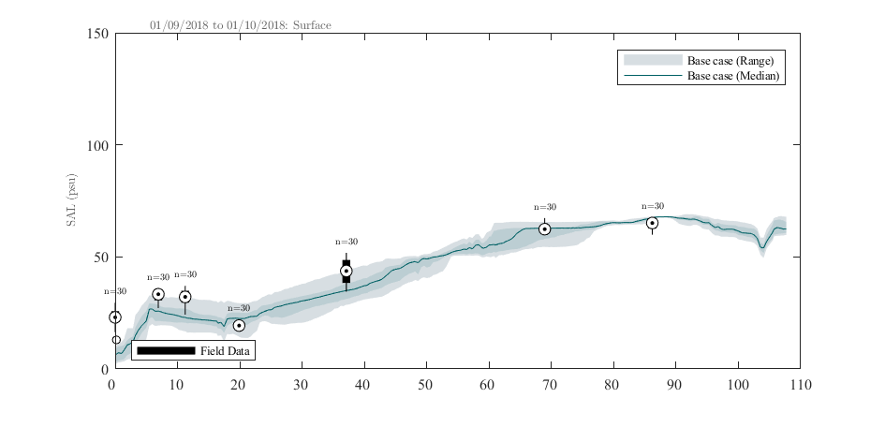

**Figure 2.3.**  Example output of transect module for salinity in the Coorong in Sep 2018 in comparison to the observations.

## 2.4 transect stacked area plotting module

The transect stacked area plotting module is a variant of the transect plotting module, and able to perform comparison of model predicted water quality components to the total observed concentration along a transect, such as comparing the modelled biomass of phytoplankton groups to the observed total chlorophyll-a concentrations. A summary of transect stacked area module configuration is provided in Table 2.4. Example configuration and output are provided after the table.

### Configuration Summary

Table 2.4 Summary of transect stacked area module configuration

|  |  |  |  |
| --- | --- | --- | --- |
| Field name | Description | Options | Comments |
| thevars | variable names of components |  | refer to the setting in master.varname |
| thelabels | labels of variables of components |  | refer to the setting in master.varname |
| thevars_conv | conversion factor of components |  | for example, 12/50 to convert phytoplankton biomass of mmol C/m2 to ug/L |
| isHTML | option to add all plots into one HTML page | 1: add to HTML; 0: no HTML | 0 by default |
| polygon_file | define the line GIS file for transect |  |  |
| outputdirectory | define directory to save plots |  |  |
| htmloutput | define directory to save HTML files |  |  |
| istitled | option to add title | 1: add; 0: not add | 1 by default |
| isylabel | option to add y label | 1: add; 0: not add | 1 by default |
| islegend | option to add legend | 1: add; 0: not add | 1 by default |
| isYlim | option to define Y axis limits | 1: add; 0: not add | 0 by default |
| isGridon | option to add grid on | 1: add; 0: not add | 1 by default |
| isSurf | option to choose surface or bottom layer | 1: surface layer; 0: bottom layer | 1 by default |
| isSpherical | option to define the coordinate type | 1: spherical; 0: Euler | 0 by default |
| add_obs-num | option to add number of observations | 1: add; 0: not add | 0 by default |
| boxlegend | define field data box plot legend location |  | 'southeast' by default |
| rangelegend | define model result legend location |  | 'northwest' by default |
| dimensions | define figure dimensions in centimeters | [20 10] by default |  |
| pdates.value | time period for transect plots |  | can define multiple periods |
| binfielddata | option to include nearby field data | 1: include; 0: not include | 1 by default |
| binradius | define the radius of bins for field data search | number with unit of km | 0.5 by default |
| linedist | distance from model polyline to be considered | number with unit of m | 500 by default |
| xlim | define limits in X axis |  |  |
| xticks | define ticks in X axis |  |  |
| xlabel | define label on X axis |  |  |
| cAxis.value | define limits of Y axis | empty [] by default, matlab will automatically adjust the y limit |  |
| filetype | define figure file type | 'png' or 'eps' | 'png' to save figures to PNG format only; 'eps' to save figures in both EPS and 300dpi JPG formats |

### Configuration Example

**Example transect stacked area configuration**

transectSA.thevars = {...

'WQ_PHY_GRN';...

'WQ_PHY_DINO';...

'WQ_PHY_DIATOM';...

'WQ_PHY_CRYPT';...

};

transectSA.thelabels = {...

'Green Algae';...

'Dino';...

'Diatom';...

'Crypt';...

};

transectSA.thevars_conv = [50 50 50 50]/12;

transectSA.varname = {...

'WQ_DIAG_PHY_TCHLA','TChla (\mug/L)';...

};

%transectSA.add_human = 1;

transectSA.polygon_file = 'E:\database\AED-MARVl-v0.2\Examples\Cockburn\GIS\Curtain_polyline_100m_QC.shp';

% Add field data to figure

transectSA.plotvalidation = 1; % 1 or 0

transectSA.pred_lims = [0.05,0.25,0.5,0.75,0.95];

transectSA.isRange = 1;

transectSA.istitled = 1;

transectSA.isylabel = 1;

transectSA.islegend = 0;

transectSA.isYlim = 1;

transectSA.isHTML = 1;

transectSA.isSurf = 1; %plot surface (1) or bottom (0)

transectSA.isSpherical = 0;

transectSA.use_matfiles = 0;

transectSA.add_obs_num = 1;

%config.boxon = 1;

% ___

transectSA.outputdirectory = 'plotting/transectSA/RAW/';

transectSA.htmloutput = 'plotting/transectSA/HTML/';

% plotting configuration

transectSA.dimc = [0.9 0.9 0.9]; % dimmest (lightest) color

transectSA.boxlegend = 'southeast';

transectSA.rangelegend = 'northwest';

transectSA.dimensions = [20 10]; % Width & Height in cm

i=1;

transectSA.pdates(1).value = [datenum(2021,06,16) datenum(2021,07,01)];i=i+1;

transectSA.pdates(2).value = [datenum(2021,07,01) datenum(2021,07,15)];i=i+1;

transectSA.pdates(3).value = [datenum(2021,07,16) datenum(2021,08,01)];i=i+1;

transectSA.binfielddata = 1;

% radius distance to include field data. Used to bin data where number of

% sites is higher, but the frequency of sampling is low. The specified

% value will also make where on the line each polygon will be created. So

% if radius == 5, then there will be a search polygon found at r*2, so 0km, 10km, 20km etc. In windy rivers these polygons may overlap.

transectSA.binradius = 0.5;% in km;

%distance from model polyline to be consided.

%Field data further than specified distance won't be included.

%Even if found with search radius. This is to attempt to exclude data

%sampled outside of the domain.

transectSA.linedist = 1500;% in m

transectSA.xlim = [0 45];% xlim in KM

transectSA.xticks = [0:5:45];

transectSA.xlabel = 'Distance from Southern CS (km)';

% ylim

transectSA.cAxis(1).value = [0 20];

### Example Output

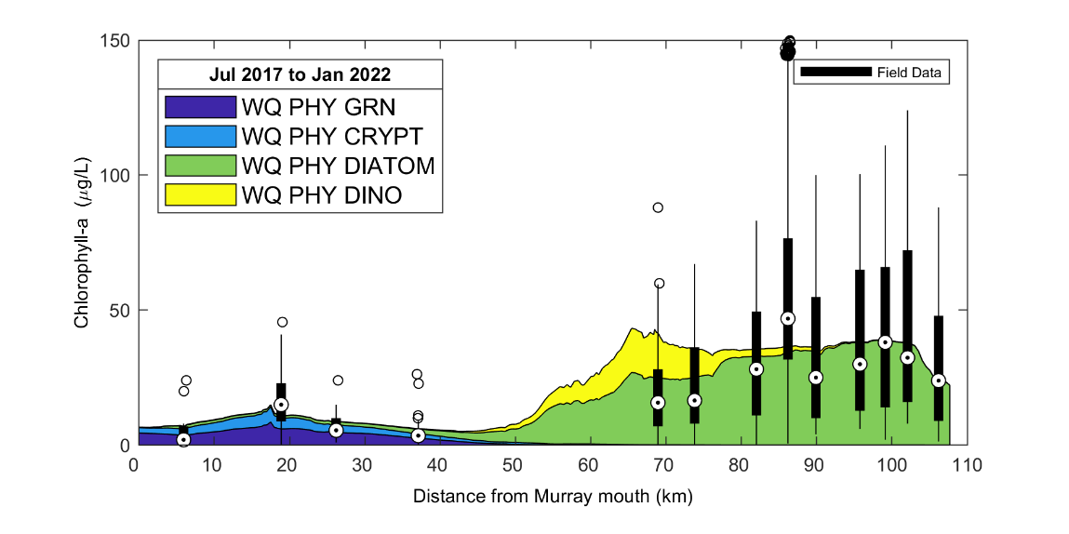

**Figure 2.3.** Example output of transect stacked area plot for phytoplankton biomass in the Coorong from 07/2017 to 01/2022.

## 2.5 transect exceedance plotting module

The transect exceedance plotting module is also a variant of the transect plotting module, and able to perform comparison of model predicted water quality against environmental guidelines or thresholds, such as comparing the predicted water quality concentrations to the ANZECC guidelines. A summary of transect exceedance module configuration is provided in Table 2.5. Example configuration and output are provided after the table.

### Configuration Summary

Table 2.5 Summary of transect exceedance module configuration

|  |  |  |  |
| --- | --- | --- | --- |
| Field name | Description | Options | Comments |
| start_plot_ID | select which variable to start plotting |  | refer to the setting in master.varname |
| end_plot_ID | select which variable to finish plotting |  | refer to the setting in master.varname |
| plotvalidation | option to add field data | 1: add field data; 0: no field data | only model data to be plotted in this module, need to be 0 |
| plotmodel | option to add model results | 1: add model results; 0: no model results | only model data to be plotted in this module, need to be 1 |
| isHTML | option to add all plots into one HTML page | 1: add to HTML; 0: no HTML | 0 by default |
| polygon_file | define the line GIS file for transect |  |  |
| outputdirectory | define directory to save plots |  |  |
| htmloutput | define directory to save HTML files |  |  |
| istitled | option to add title | 1: add; 0: not add | 1 by default |
| isylabel | option to add y label | 1: add; 0: not add | 1 by default |
| islegend | option to add legend | 1: add; 0: not add | 1 by default |
| isYlim | option to define Y axis limits | 1: add; 0: not add | 0 by default |
| isGridon | option to add grid on | 1: add; 0: not add | 1 by default |
| isSurf | option to choose surface or bottom layer | 1: surface layer; 0: bottom layer | 1 by default |
| isSpherical | option to define the coordinate type | 1: spherical; 0: Euler | 0 by default |
| thresh.value | threshold values to be added onto plots |  | user can define multiple thresholds |
| thresh.legend | legends for thresholds |  | string array match the value size |
| boxlegend | define field data box plot legend location |  | 'southeast' by default |
| rangelegend | define model result legend location |  | 'northwest' by default |
| dimensions | define figure dimensions in centimeters | [20 10] by default |  |
| pdates.value | time period for transect plots |  | can define multiple periods |
| binfielddata | option to include nearby field data | 1: include; 0: not include | 1 by default |
| binradius | define the radius of bins for field data search | number with unit of km | 0.5 by default |
| linedist | distance from model polyline to be considered | number with unit of m | 500 by default |
| xlim | define limits in X axis |  |  |
| xticks | define ticks in X axis |  |  |
| xlabel | define label on X axis |  |  |
| cAxis.value | define limits of Y axis | empty [] by default, matlab will automatically adjust the y limit |  |
| filetype | define figure file type | 'png' or 'eps' | 'png' to save figures to PNG format only; 'eps' to save figures in both EPS and 300dpi JPG formats |

### Configuration Example

**Example transect exceedance module configuration**

transectExc.start_plot_ID = 13;

transectExc.end_plot_ID = 13;

transectExc.polygon_file = 'E:\database\AED-MARVl-v0.2\Examples\Cockburn\GIS\Curtain_polyline_100m_QC.shp';

% Add field data to figure

transectExc.plotvalidation = 0; % 1 or 0

transectExc.pred_lims = [0.05,0.25,0.5,0.75,0.95];

transectExc.isRange = 1;

transectExc.istitled = 1;

transectExc.isylabel = 1;

transectExc.islegend = 0;

transectExc.isYlim = 1;

transectExc.isHTML = 1;

transectExc.isSurf = 1; %plot surface (1) or bottom (0)

transectExc.isSpherical = 0;

%transectExc.use_matfiles = 0;

%transectExc.add_obs_num = 1;

%config.boxon = 1;

transectExc.thresh(13).value = [0.5 1];

transectExc.thresh(13).legend = {'%time > 0.5NTU',...

'%time > 1NTU'};

% ___

transectExc.outputdirectory = 'plotting/transect_exceedance/RAW/';

transectExc.htmloutput = 'plotting/transect_exceedance/HTML/';

% plotting configuration

transectExc.dimc = [0.9 0.9 0.9]; % dimmest (lightest) color

transectExc.boxlegend = 'southeast';

transectExc.rangelegend = 'northwest';

transectExc.dimensions = [20 10]; % Width & Height in cm

i=1;

transectExc.pdates(1).value = [datenum(2021,06,16) datenum(2021,07,01)];i=i+1;

transectExc.pdates(2).value = [datenum(2021,07,01) datenum(2021,07,15)];i=i+1;

transectExc.pdates(3).value = [datenum(2021,07,16) datenum(2021,08,01)];i=i+1;

transectExc.binfielddata = 1;

% radius distance to include field data. Used to bin data where number of

% sites is higher, but the frequency of sampling is low. The specified

% value will also make where on the line each polygon will be created. So

% if radius == 5, then there will be a search polygon found at r*2, so 0km, 10km, 20km etc. In windy rivers these polygons may overlap.

transectExc.binradius = 0.5;% in km;

%distance from model polyline to be consided.

%Field data further than specified distance won't be included.

%Even if found with search radius. This is to attempt to exclude data

%sampled outside of the domain.

transectExc.linedist = 1500;% in m

transectExc.xlim = [0 45];% xlim in KM

transectExc.xticks = [0:5:45];

transectExc.xlabel = 'Distance from Southern CS (km)';

% ylim

for vvvv=1:size(MARVLs.master.varname,1)

transectExc.cAxis(vvvv).value = [0 100];

end

transectExc.ncfile(1).symbol = {'-'};

transectExc.ncfile(1).translate = 1;

transectExc.ncfile(1).colour = [166,86,40]./255;% Surface and Bottom

transectExc.ncfile(1).edge_color = [166,86,40]./255;

transectExc.ncfile(1).col_pal_color =[[176 190 197]./255;[162 190 197]./255;[150 190 197]./255;[150 190 197]./255];

### Example Output

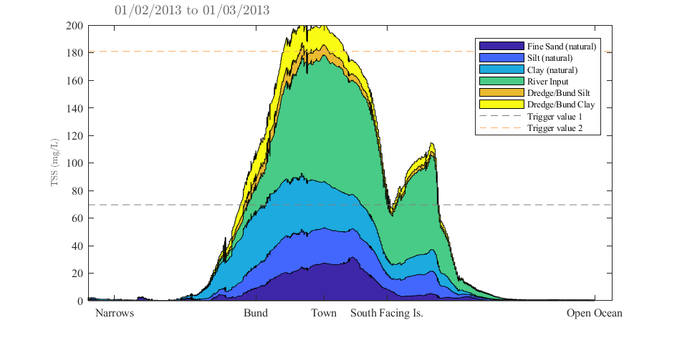

**Figure 2.5.** Example transect exceedance plot for suspended solids concentration against guidelines in Gladstone.

## 2.6 site profiling plotting module

The site profiling plotting module is a simple module for plotting selected water quality at one or multiple sites. A summary of site profiling module configuration is provided in Table 2.6. Example configuration and output are provided after the table.

### Configuration Summary

Table 2.5 Summary of site profiling module configuration

|  |  |  |  |
| --- | --- | --- | --- |
| Field name | Description | Options | Comments |
| start_plot_ID | select which variable to start plotting |  | refer to the setting in master.varname |
| end_plot_ID | select which variable to finish plotting |  | refer to the setting in master.varname |
| sitenames | names of plotting sites |  | can define multiple sites |
| siteX | X coordinates of sites |  | same array size to site names |
| siteY | Y coordinates of sites |  | same array size to site names |
| plotvalidation | option to add field data | 1: add field data; 0: no field data | currently only model data can be plotted |
| plotmodel | option to add model results | 1: add model results; 0: no model results |  |
| isHTML | option to add all plots into one HTML page | 1: add to HTML; 0: no HTML | 0 by default |
| outputdirectory | define directory to save plots |  |  |
| htmloutput | define directory to save HTML files |  |  |
| datearray | define time period for plotting |  |  |
| dateformat | define time format to show in x axis | mm/yy' by default |  |
| istitled | option to add title | 1: add; 0: not add | 1 by default |
| isylabel | option to add y label | 1: add; 0: not add | 1 by default |
| islegend | option to add legend | 1: add; 0: not add | 1 by default |
| isYlim | option to define Y axis limits | 1: add; 0: not add | 0 by default |
| isGridon | option to add grid on | 1: add; 0: not add | 1 by default |
| dimensions | define figure dimensions in centimeters | [20 10] by default |  |
| filetype | define figure file type | 'png' or 'eps' | 'png' to save figures to PNG format only; 'eps' to save figures in both EPS and 300dpi JPG formats |
| cAxis.value | define limits of Y axis | empty [] by default, matlab will automatically adjust the y limit |  |

### Configuration Example

**Example site profiling module configuration**

profile.start_plot_ID = 1;

profile.end_plot_ID = 1;

profile.sitenames={'Cockburn','Swan'};

profile.siteX=[ 380000, 388340];

profile.siteY=[6433760,6458300];

profile.plotvalidation = false; % Add field data to figure (true or false)

profile.plotmodel = 1;

profile.filetype = 'eps';

profile.expected = 1; % plot expected WL

profile.isHTML = 1;

profile.datearray = datenum(2021,6,15:15:60);

profile.dateformat = 'dd/mm/yyyy';

for vvvv=1:length(MARVLs.master.varname)

profile.cAxis(vvvv).value = [ ];

end

profile.dimc = [0.9 0.9 0.9]; % dimmest (lightest) color

profile.istitled = 1;

profile.isylabel = 1;

profile.islegend = 1;

profile.isYlim = 1;

profile.isGridon = 1;

profile.dimensions = [20 10]; % Width & Height in cm

profile.outputdirectory = 'plotting/profile/RAW/';

profile.htmloutput = 'plotting/profile/HTML/';

### Example Output

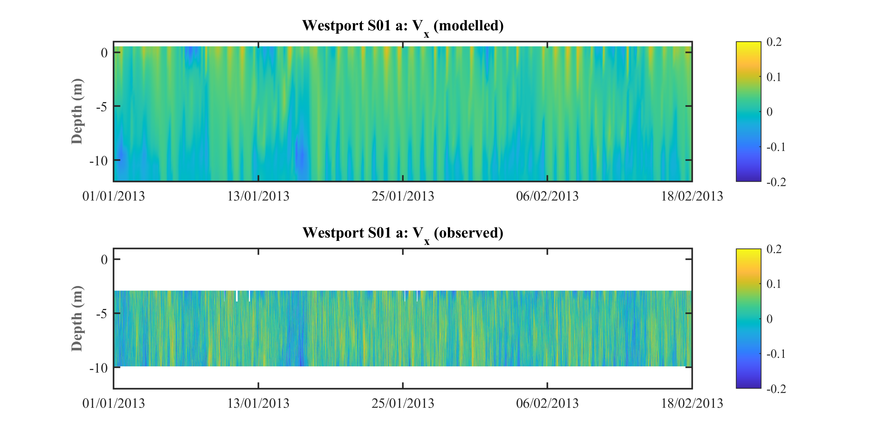

**Figure 2.6** Example site profiling output for eastern current speeds at site of S01 of Cockburn Sound.

## 2.7 sheet map plotting module

The sheet map plotting module can be configured to plot sheet maps or movies of selected water quality variables within define model domain. The module also has options to include m_map tool package for large domain and add current vectors on the map. A summary of sheet map module configuration is provided in Table 2.7. Example configuration and output are provided after the table.

### Configuration Summary

Table 2.7 Summary of sheet map module configuration

|  |  |  |  |
| --- | --- | --- | --- |
| Field name | Description | Options | Comments |
| start_plot_ID | select which variable to start plotting |  | refer to the setting in master.varname |
| end_plot_ID | select which variable to finish plotting |  | refer to the setting in master.varname |
| plotdepth | choose from surface or bottom layer | surface or bottom |  |
| Style | choose from ‘m_map’ or ‘none’ | ‘m_map’ or ‘none’ |  |
| plottype | choose from ‘figure’ or ‘movie’ | ‘figure’ or ‘movie’ |  |
| meshtype | choose from ‘patch’ or ‘meshgrid’ | ‘patch’: use original TFV mesh;  ‘meshgrid’: interpolate TFV outputs into mesh grid; |  |
| add_quiver | Option to include current vectors | 1: include; 0: not include |  |
| add_coastline | Option to include coastal line onto map | 1: include; 0: not include |  |
| coastline_file | File path of the coastline data |  | Work only when add_coastline = 1; and the data is saved in a .mat format; |
| xlim | Define the x axis limit |  |  |
| ylim | Define the y axis limit |  |  |
| FileFormat | define movie format | choose mp4 or avi |  |
| Quality | define movie quality |  | 100 by default |
| FrameRate | define movie frame rate |  | 6 by default |
| resolution | define movie/figure resolution |  | [1024,768] by default |
| colormap | define color map type | check matlab help for colormap options |  |
| save_image | option to save frames to images | 1: save; 0: not save; |  |
| datearray | define time period for move |  |  |
| dateformat | define date format in movie |  |  |
| plot_interval | define interval to plot |  | refer to model output intervals |
| outputdirectory | define directory to save plots |  |  |
| htmloutput | define directory to save HTML files |  |  |
| clip_depth | define minimum depth to remove NaN values |  | 0.05 by default |
| istitled | option to add title | 1: add; 0: not add | 1 by default |
| isColorbar | option to add colorbar | 1: add; 0: not add | 1 by default |
| isylabel | option to add y label | 1: add; 0: not add | 1 by default |
| islegend | option to add legend | 1: add; 0: not add | 1 by default |
| isYlim | option to define Y axis limits | 1: add; 0: not add | 0 by default |
| isGridon | option to add grid on | 1: add; 0: not add | 1 by default |
| dimensions | define figure dimensions in centimeters | [20 10] by default |  |
| cAxis.value | define color caxis limits | empty [] by default, matlab will automatically adjust the y limit |  |

### Configuration Example

**Example sheet map module configuration**

sheet.start_plot_ID = 1;

sheet.end_plot_ID = 1;

sheet.style = 'm_map'; % choose 'm_map'(default) or 'none' to use 'm_map14' library

sheet.add_ruler = 1; % 1/0: add/no ruler (default), work only for m_map option

sheet.plotdepth = {'bottom'}; % {'surface','bottom'} Cell-array with either one

sheet.meshstype = 'meshgrid'; % choose 'patch' or 'meshgrid'

sheet.add_quiver = 1; % 1/0: add/no current vector, work only for 'meshgrid' option

sheet.add_coastline = 1; % 1/0: add/no coast line

sheet.coastline_file = './GIS/Boundary.shp'; % 1/0: add/no coast line

sheet.plottype = 'movie'; % choose 'movie' or 'figure';

sheet.xlim=[115.6666 115.7786]; %[115.6089 115.7786]; %

sheet.ylim=[-32.3000 -32.1333]; %[-32.3206 -31.9921]; %

if strcmpi(sheet.plottype,'movie')

sheet.FileFormat='mp4'; % choose 'mp4' or 'avi'

sheet.Quality =100; % movie quality

sheet.FrameRate =6; % frame rate

sheet.resolution = [1024,768]; % frame rosolution

sheet.colormap = 'jet'; % colormap options, see Matlab manual

sheet.save_images = 1; % option to save slide images

sheet.datearray = [datenum(2021,07,01) datenum(2021,07,21)];

sheet.dateformat = 'mm/yyyy';

sheet.plot_interval = 6;

elseif strcmpi(sheet.plottype,'figure')

sheet.datearray = [datenum(2021,07,01) datenum(2021,07,21)];

sheet.resolution = [1024,768]; % frame rosolution

sheet.colormap = 'jet'; % colormap options, see Matlab manual

else

msg=['Error: type of ',sheet.plottype,' is not recognized'];

error(msg);

end

sheet.outputdirectory = 'plotting/sheet/';

sheet.clip_depth = 0.05; % remove the shallow NaN cells

sheet.cAxis(1).value = [28 35];

sheet.dimc = [0.9 0.9 0.9]; % dimmest (lightest) color

sheet.istitled = 1;

sheet.isColorbar = 1;

sheet.Xlim = [ ];

sheet.Ylim = [ ];

sheet.isAxison = 1;

sheet.dimensions = [20 10]; % Width & Height in cm

### Example Output

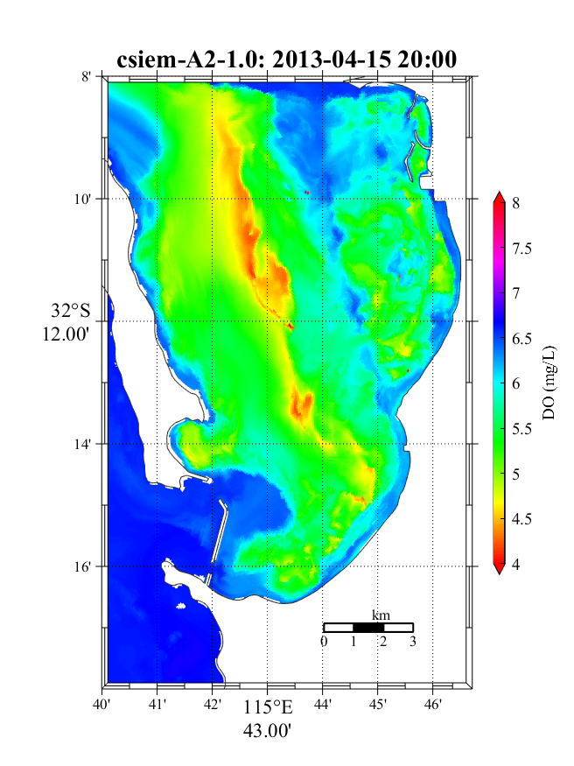

**Figure 2.7** Example sheet map output for bottom oxygen at Western Australia coastal area.

## 2.8 curtain plotting module

The curtain plotting module can also be configured to plot curtain views in pictures or movies of selected water quality variables along a defined polyline. The module also has options to add current vectors on the map. A summary of curtain module configuration is provided in Table 2.8. Example configuration and output are provided after the table.

### Configuration Summary

Table 2.8 Summary of curtain plotting module configuration

|  |  |  |  |
| --- | --- | --- | --- |
| Field name | Description | Options | Comments |
| start_plot_ID | select which variable to start plotting |  | refer to the setting in master.varname |
| end_plot_ID | select which variable to finish plotting |  | refer to the setting in master.varname |
| meshtype | choose from ‘patch’ or ‘meshgrid’ | ‘patch’: use original TFV mesh;  ‘meshgrid’: interpolate TFV outputs into mesh grid; |  |
| add_quiver | Option to include current vectors | 1: include; 0: not include |  |
| add_coastline | Option to include coastal line onto map | 1: include; 0: not include |  |
| polyline | File path of the polyline |  |  |
| Quality | define movie quality |  | 100 by default |
| FrameRate | define movie frame rate |  | 6 by default |
| resolution | define movie/figure resolution |  | [1024,768] by default |
| colormap | define color map type | check matlab help for colormap options |  |
| save_image | option to save frames to images | 1: save; 0: not save; |  |
| datearray | define time period for move |  |  |
| dateformat | define date format in movie |  |  |
| plot_interval | define interval to plot |  | refer to model output intervals |
| outputdirectory | define directory to save plots |  |  |
| htmloutput | define directory to save HTML files |  |  |
| clip_depth | define minimum depth to remove NaN values |  | 0.05 by default |
| istitled | option to add title | 1: add; 0: not add | 1 by default |
| isColorbar | option to add colorbar | 1: add; 0: not add | 1 by default |
| xlim | define limits in X axis |  |  |
| xticks | define ticks in X axis |  |  |
| xlabel | define label on X axis |  |  |
| isylabel | option to add y label | 1: add; 0: not add | 1 by default |
| islegend | option to add legend | 1: add; 0: not add | 1 by default |
| isYlim | option to define Y axis limits | 1: add; 0: not add | 0 by default |
| isGridon | option to add grid on | 1: add; 0: not add | 1 by default |
| dimensions | define figure dimensions in centimeters | [20 10] by default |  |
| cAxis.value | define limits of Y axis | empty [] by default, matlab will automatically adjust the y limit |  |
| colorbarposition | define position of color bar |  |  |

### Configuration Example

**Example curtain plotting configuration**

curtain.start_plot_ID = 1;

curtain.end_plot_ID = 1;

curtain.polyline = 'W:/Jayden/plotting/Curtain_polyline_100m_QC.shp';

curtain.meshstype = 'meshgrid'; % choose 'patch' or 'meshgrid'

curtain.add_quiver = 1; % 1/0: add/no current vector, work only for 'meshgrid' option

curtain.plottype = 'movie'; % choose 'movie' or 'figure';

if strcmpi(curtain.plottype,'movie')

curtain.FileFormat='mp4'; % choose 'mp4' or 'avi'

curtain.Quality =100; % movie quality

curtain.FrameRate =6; % frame rate

curtain.resolution = [1024,768]; % frame rosolution

curtain.colormap = 'jet'; % colormap options, see Matlab manual

curtain.save_images = 1; % option to save slide images

curtain.datearray = [datenum(2021,07,01) datenum(2021,07,21)];

curtain.dateformat = 'mm/yyyy';

curtain.plot_interval = 6;

elseif strcmpi(curtain.plottype,'figure')

curtain.datearray = [datenum(2021,07,01) datenum(2021,07,21)];

curtain.resolution = [1024,768]; % frame rosolution

curtain.colormap = 'jet'; % colormap options, see Matlab manual

else

msg=['Error: type of ',curtain.plottype,' is not recognized'];

error(msg);

end

curtain.outputdirectory = 'plotting/curtain/';

curtain.clip_depth = 0.05; % remove the shallow NaN cells

curtain.dimc = [0.9 0.9 0.9]; % dimmest (lightest) color

curtain.istitled = 1;

curtain.isColorbar = 1;

curtain.xlim = [0 45];% xlim in KM

curtain.xticks = [0:5:45];

curtain.xlabel = 'Distance from CS South (km)';

curtain.isAxison = 1;

curtain.dimensions = [20 10]; % Width & Height in cm

curtain.colorbarposition = [0.92 0.25 0.01 0.45];

curtain.cAxis(1).value = [28 35];

### Output Example

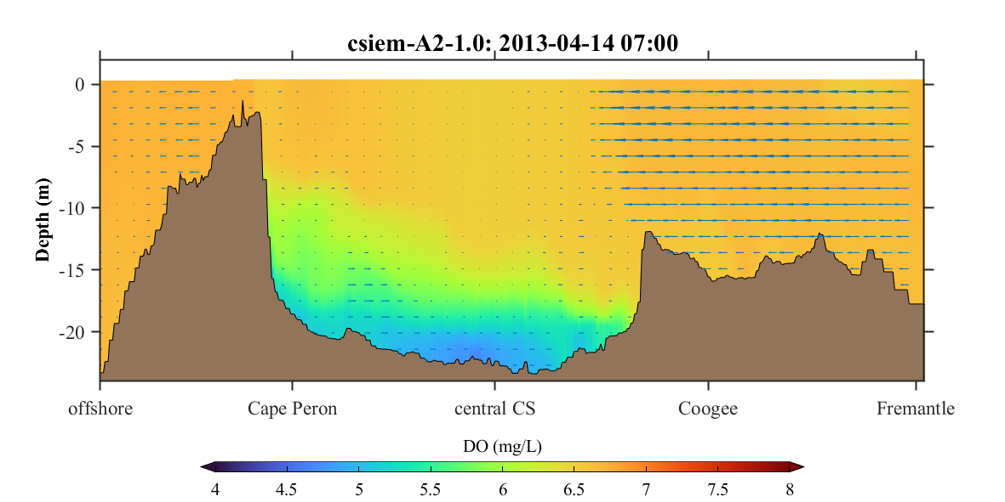

**Figure 2.8** Example curtain plot output for dissolved oxygen along a polyline of Cockburn Sound.

# References

Hipsey, M.R., Kilminster, K., Busch, B.D., Bruce, L.C. and Larsen, S. (2014) Modelling oxygen dynamics in the Upper Swan estuary and Canning Weir Pool. *AED Report #R25*, The University of Western Australia, Perth, Australia. 99pp.

Hipsey, M.R., Kilminster, K., Busch B., 2016a. The Swan-Canning Estuary Response Model (SCERM) v1: Model validation and performance assessment. AED Report #R29, The University of Western Australia, Perth, Australia. 42pp.

Hipsey, M.R., Kilminster, K., Robinson, S., Gedaria. A, Trayler, K., 2016b. The Swan-Canning Estuary Response Model (SCERM) v1: Model Science Basis and Parameterisation. *AED Report #R28*, The University of Western Australia, Perth, Australia. 50pp.

Bennett, N.D., Croke, B.F.W., Guariso, G., Guillaume, J.H.A., Hamilton, S.H., Jakeman, A.J., Marsili-Libelli, S., Newham, L.T.H., Norton, J.P., Perrin, C., Pierce, S. A., Robson, B., Seppelt, R., Voinov, A.A., Fath, B.D., Andreassian, V., 2013. Characterising performance of environmental models. Environ. Model. Software 40, 1–20.

Hipsey, M.R. et al., 2020. A system of metrics for the assessment and improvement of aquatic ecosystem models. Environmental Modelling and Software, 128, 104697.